DBMS: Experiment 2

DDL

Data Definition Language (DDL) statements are used to define the database structure or schema. Data Definition Language describes how the data should exist in the database, therefore language statements like CREATE TABLE or ALTER TABLE belong to the DDL. DDL is about "metadata".

DDL includes commands such as CREATE, ALTER, and DROP statements.DDL are used to CREATE, ALTER, OR DROP the database objects (Table, Views, Users).

Data Definition Language (DDL) is used in different statements :
- CREATE - to create objects in the database
- ALTER - alters the structure of the database
- DROP - delete objects from the database
- TRUNCATE - remove all records from a table, including all spaces allocated for the records are removed
- COMMENT - add comments to the data dictionary
- RENAME - rename an object

A) CREATE TABLE

Syntax:
CREATE TABLE table_name(
Col_name1 datatype(),
Col_name2 datatype(),…
Col_namen datatype(),
);

Example: Here, we are creating a sample table.
- CREATE TABLE DDL
- (
- id int,
- DDL_Type varchar(50),
- DDL_Value int
- );
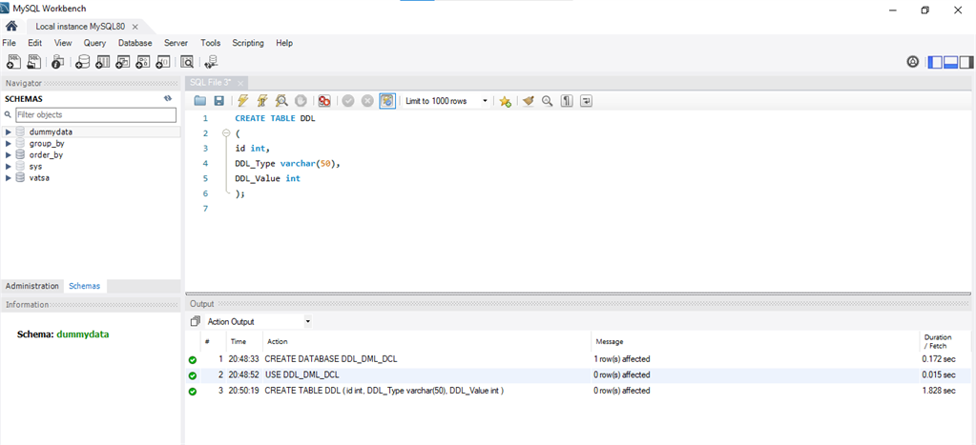

B) ALTER TABLE

1) ADD

Syntax:
ALTER TABLE table_name
ADD Col_name datatype()...;

Example: Here, we are adding a new column to the existing table.
- ALTER TABLE DDL
- ADD COLUMN DDL_Example varchar(50);
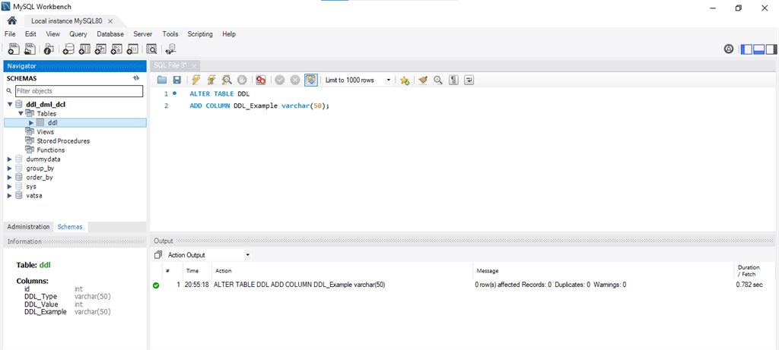

2) MODIFY

Syntax:
ALTER TABLE table_name
MODIFY (fieldname datatype()...);

Example: Modify a datatype in an existing table.
- ALTER TABLE DDL
- MODIFY DDL_Example BIGINT;
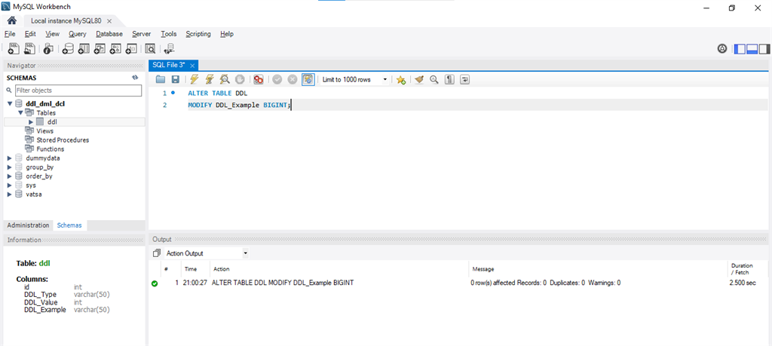

C) DESCRIBE TABLE

Syntax:
DESCRIBE TABLE NAME;

Example: This query is used to view the table.
- DESCRIBE DDL;
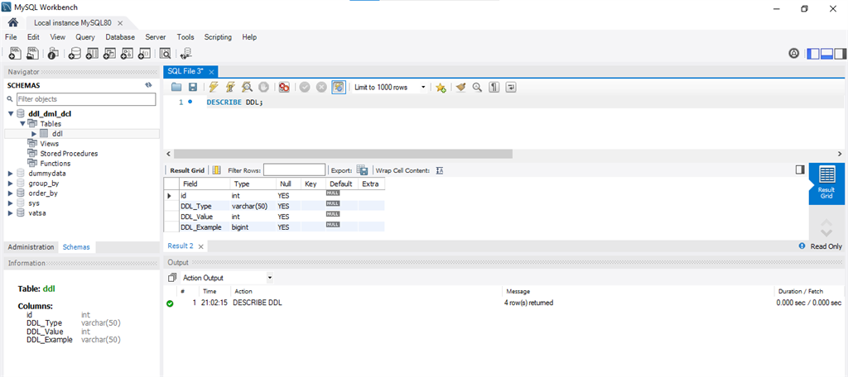

D) DROP TABLE

Syntax:
DROP Table name;

Example: Used to drop a table.
- DROP TABLE DDL;
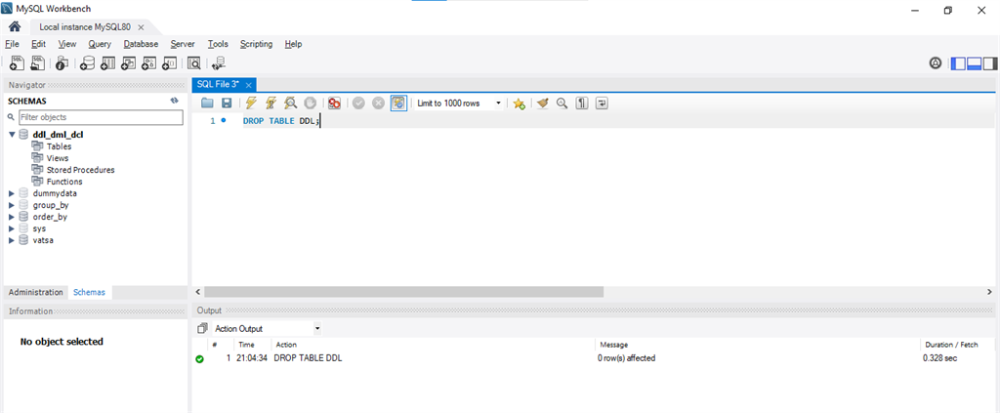

E) COMMENT

Add comments to the data dictionary

F) RENAME

Rename a table

Syntax:
RENAME table table_name to new table_name

DML

Data Manipulation Language (DML) statements are used for managing data within schema objects DML deals with data manipulation, and therefore includes most common SQL statements such as SELECT, INSERT, etc. DML allows adding / modifying / deleting data itself.

DML is used to manipulate the existing data in the database objects (insert, select, update, delete).

DML Commands

1.INSERT
2.SELECT
3.UPDATE
4.DELETE

1) INSERT

Syntax:
INSERT INTO Table_Name VALUES();

Example: Here, we are going to insert some values.
- INSERT INTO DDL (id, DDL_Type, DDL_Value) VALUES
- (2, 'DML', 123),
- (3, 'DCL', 123);
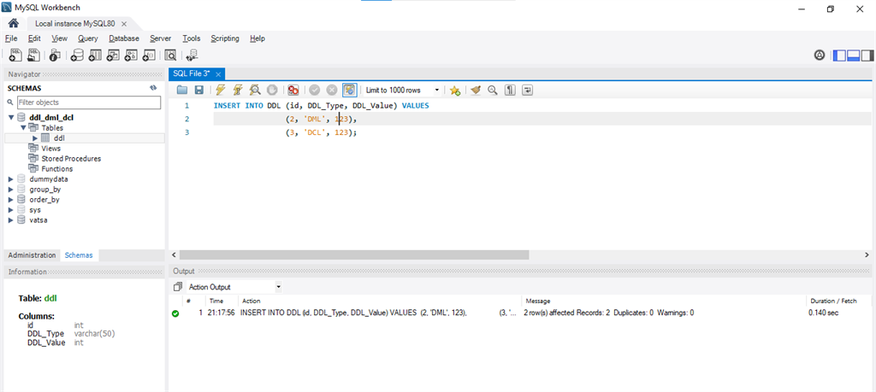

2) SELECT

Syntax:
SELECT * FROM <table_name>

Example: select query is used to fetch the data from tables.
- SELECT * FROM DDL
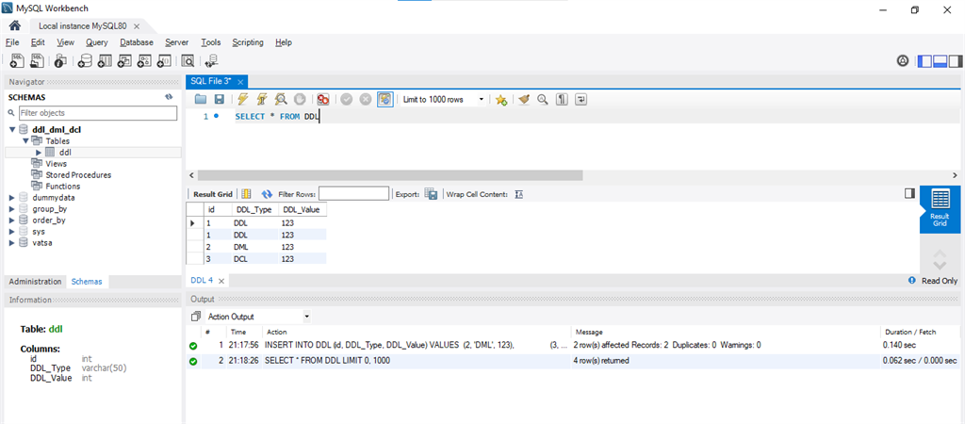

3) UPDATE

Syntax:
UPDATE <table name> set to(calculation);

Example: Update command is used to update any value from any table.
- UPDATE ddl
- SET DDL_Value = 555 WHERE DDL_Type = 'DML';
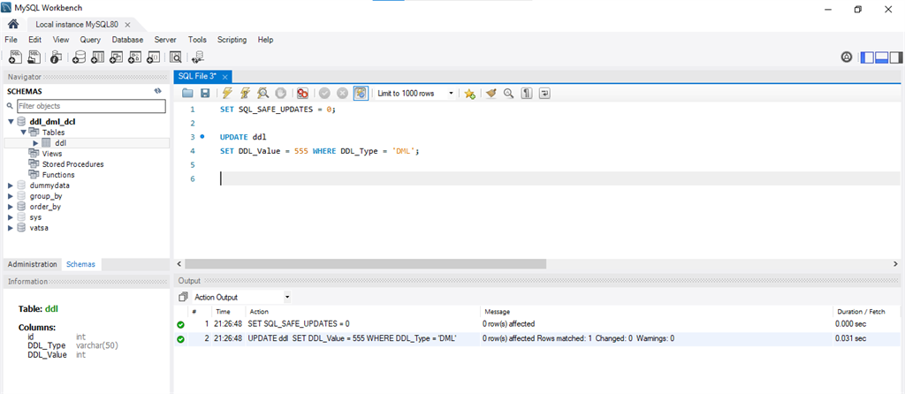

4) DELETE

Syntax:
DELETE FROM <table_name>

Example: Delete query is used to delete a row from a table.
- DELETE FROM DDL
- Where id = 2
